Indian’s Agriculture Crops Production Analysis(1997-2021)

Introduction:

This report delves into the captivating realm of India's agricultural cultivation, providing a comprehensive visual exploration of key aspects and trends in the agricultural sector. Through the visual representations, readers can gain valuable insights into crop production, seasonal variations, regional distribution, and overall production trends. These visualizations enable intuitive analysis, allowing stakeholders to uncover patterns, identify areas of growth or concern, and make data-driven decisions. By harnessing the power of Tableau, this report not only presents the data in a visually appealing manner but also provides an interactive experience for readers to explore the intricacies of India's agricultural cultivation. To Extract the Insights from the data and put the data in the form of visualizations, Dashboards and Story we employed Tableau tool.

* 1. Overview:  
     Its gross irrigated crop area of 82.6 million hectares (215.6 million acres) is the largest in the world. India is among the top three global producers of many crops, including wheat, rice, pulses, cotton, peanuts, fruits and vegetables.
  2. Purpose:

Agriculture has been the backbone of the Indian economy and it will continue to remain so for a long time. It has to support almost 17 per cent of world population from 2.3 per cent of world geographical area and 4.2 per cent of world's water resources.

2. Problem Statement & Design thinking:

Problem of Indian Agricultural:

The present challenges that plague Indian agriculture are limited knowledge and insufficient infrastructure, especially in the rural areas. Problems related to lack of infrastructure, such as irrigation, market and transport, add huge costs to farmers' operations. In addition, there are no proper delivery systems.

Design thining:

Designing farming equipment: Design thinking can be used to design farming equipment that is more efficient, safer, and easier to use. For example, a company could use design thinking to create a new harvester that is more versatile and adaptable to different crops

2.1 Empathy map:

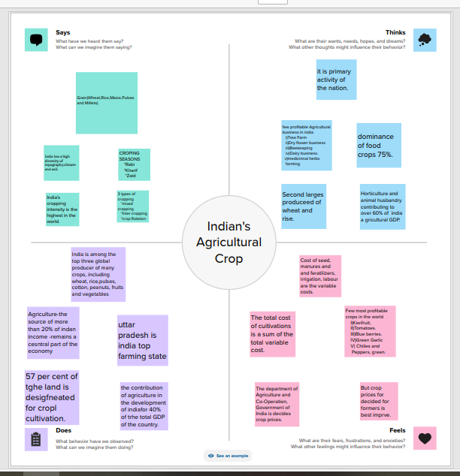

2.2. Ideation and Brainstorming Map:

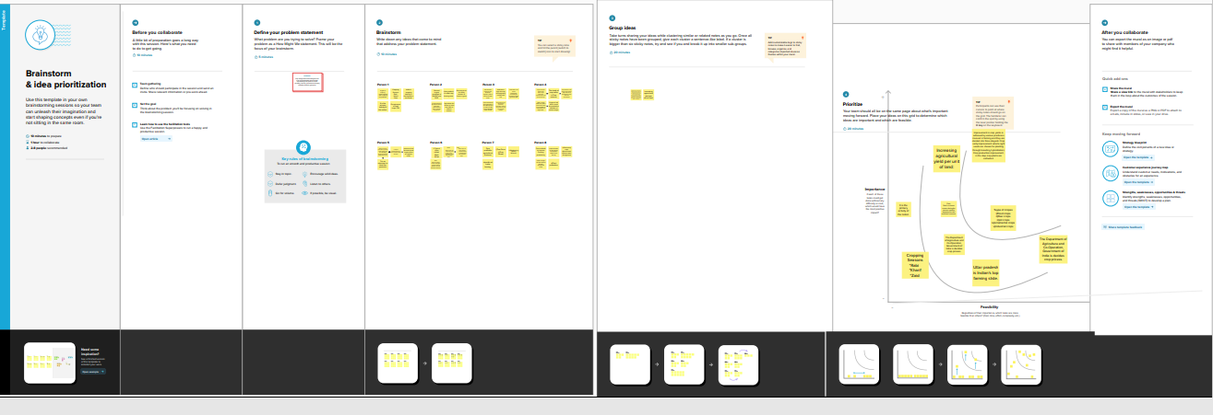

3. Result

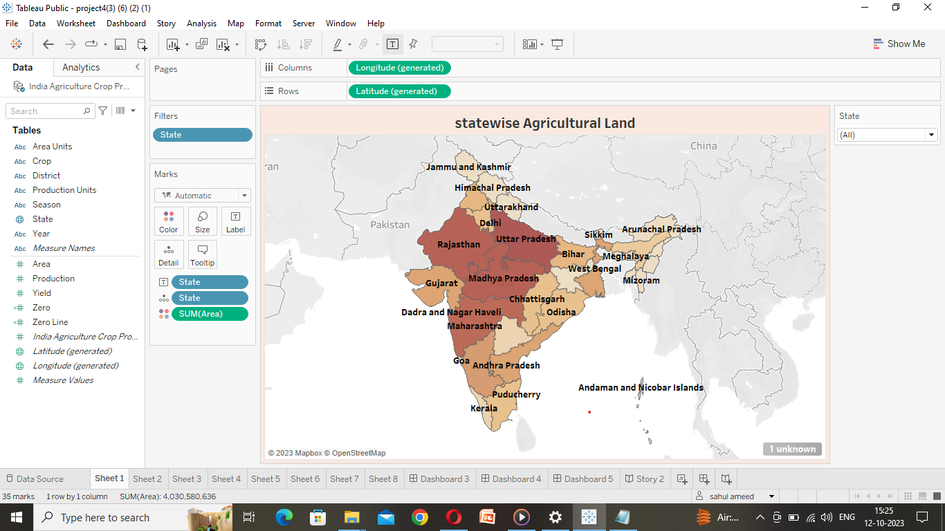

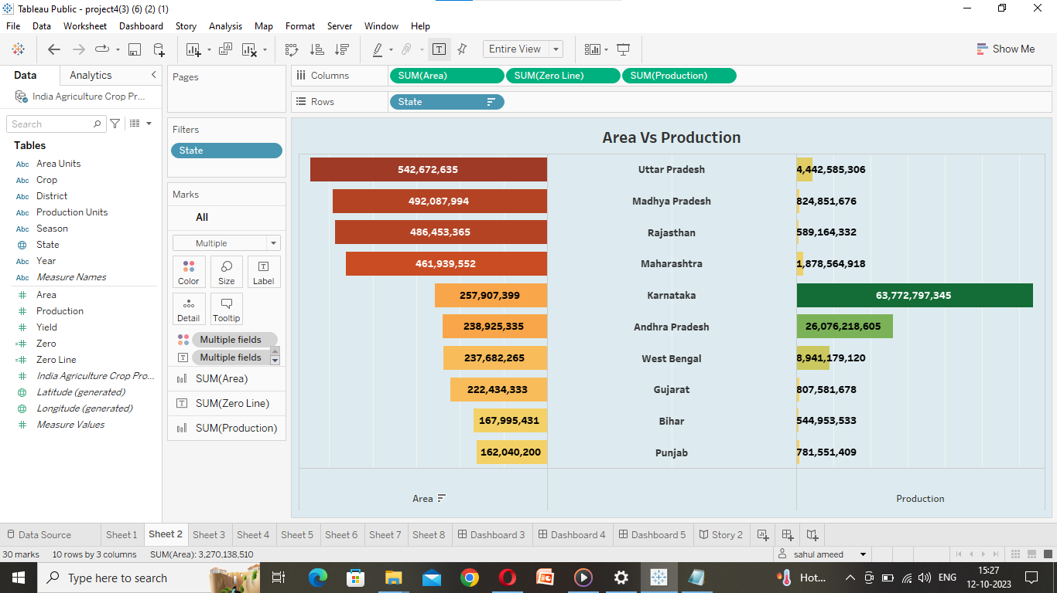

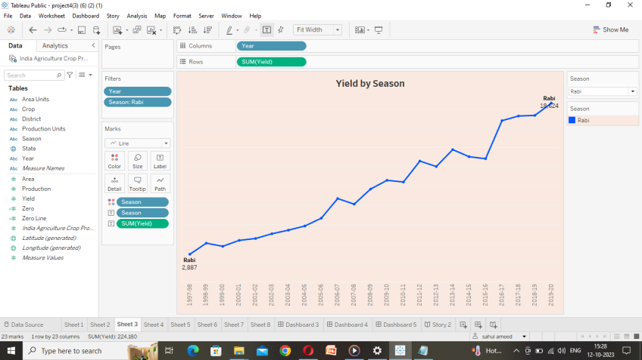

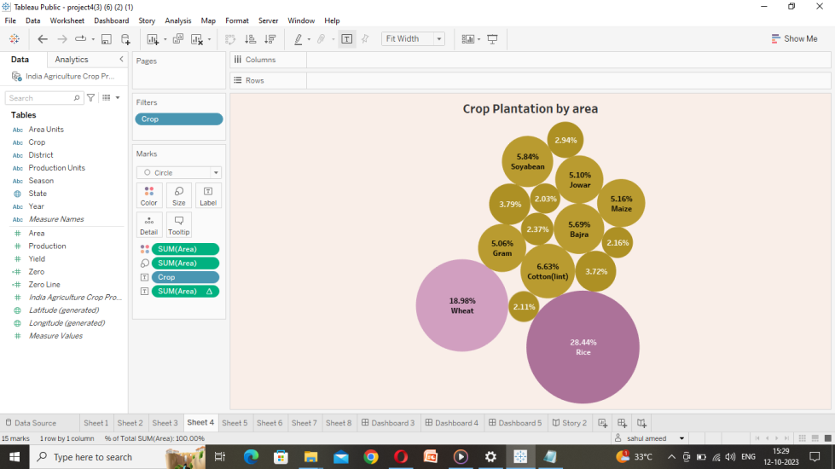

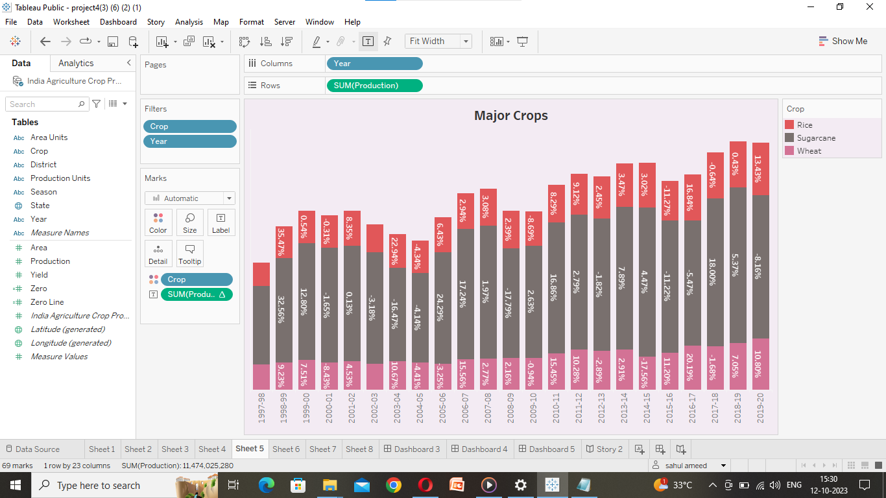

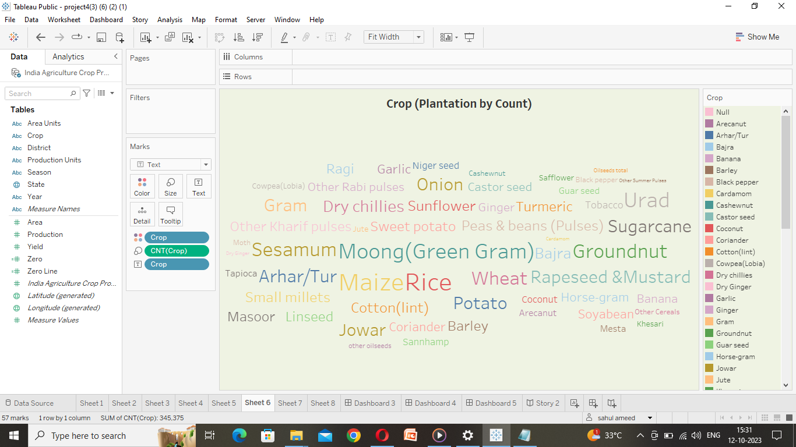

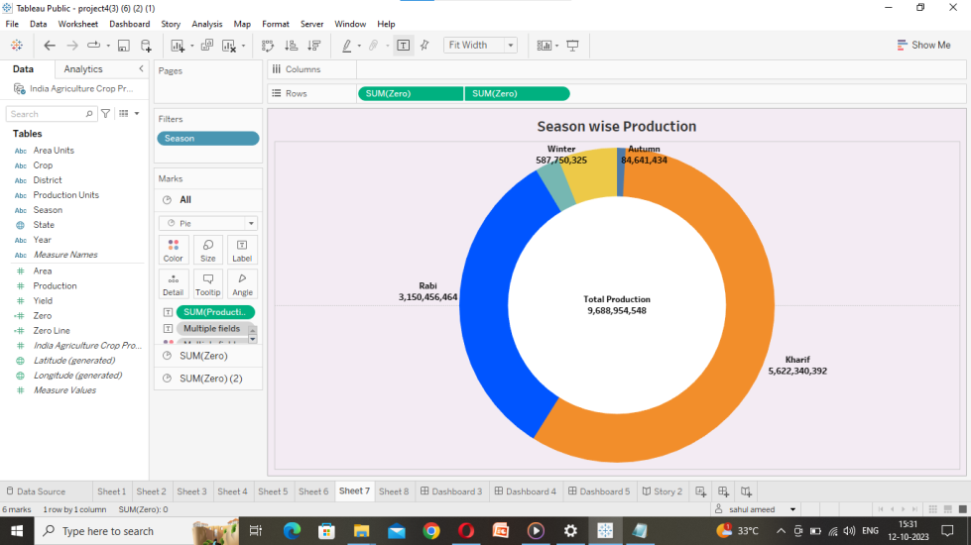

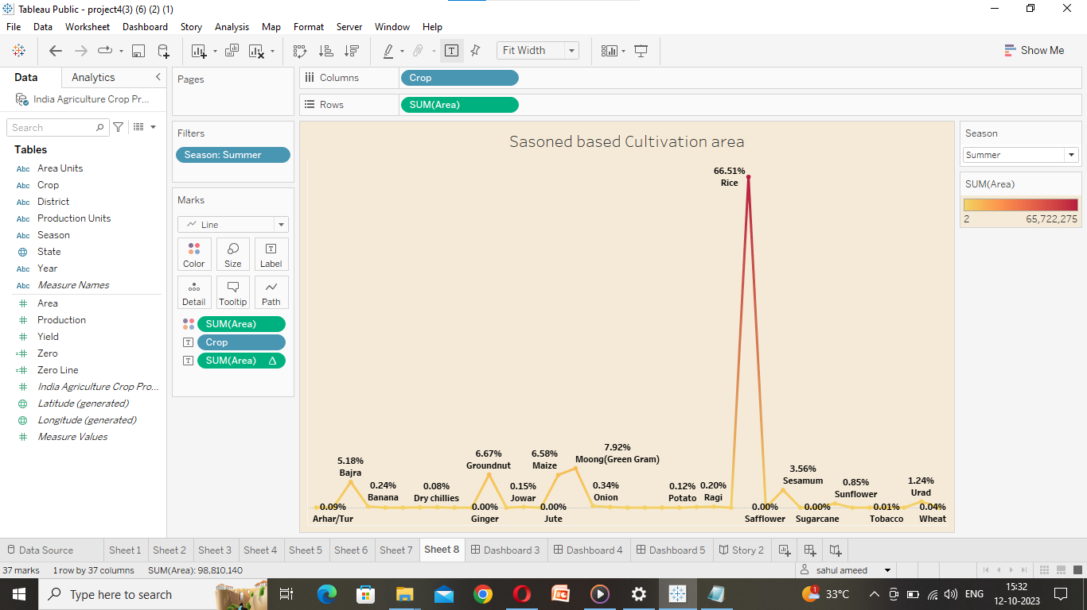

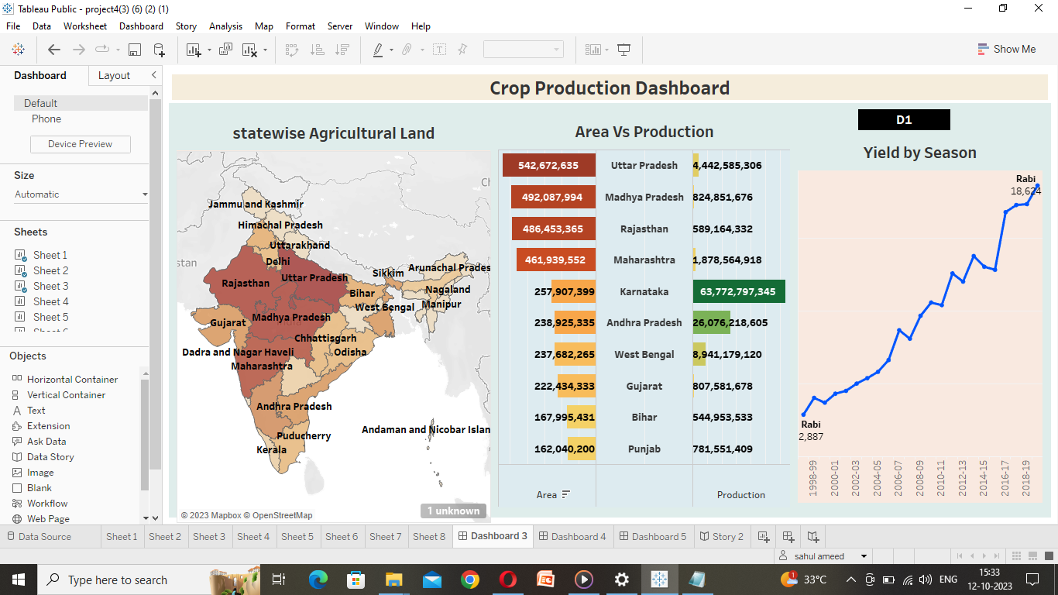

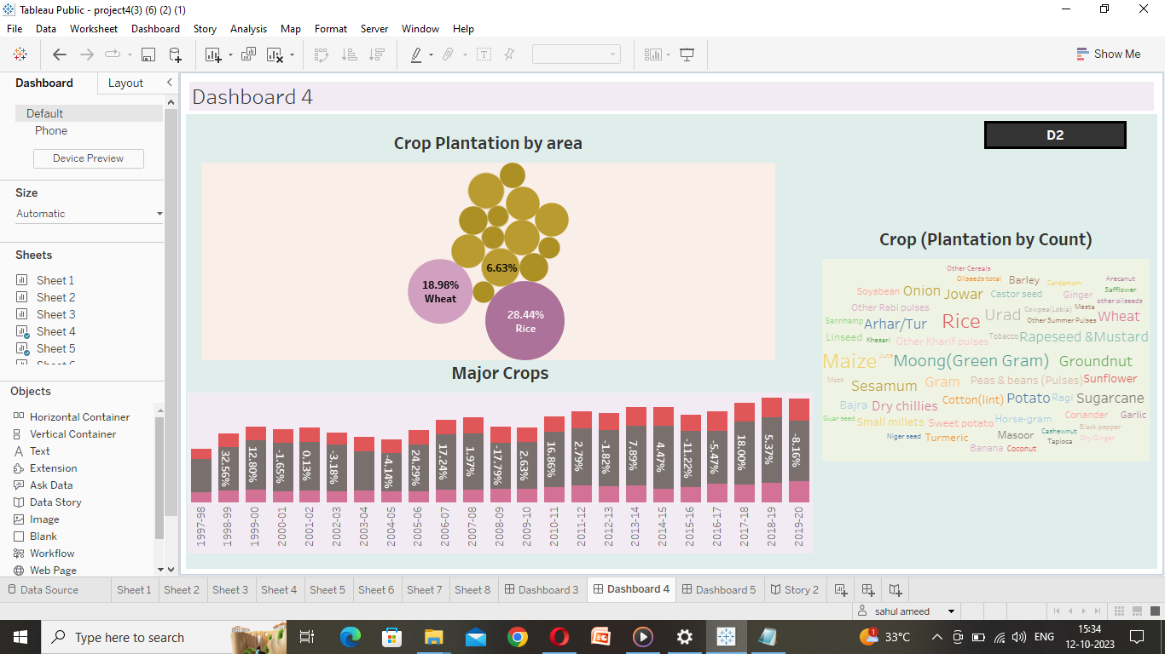

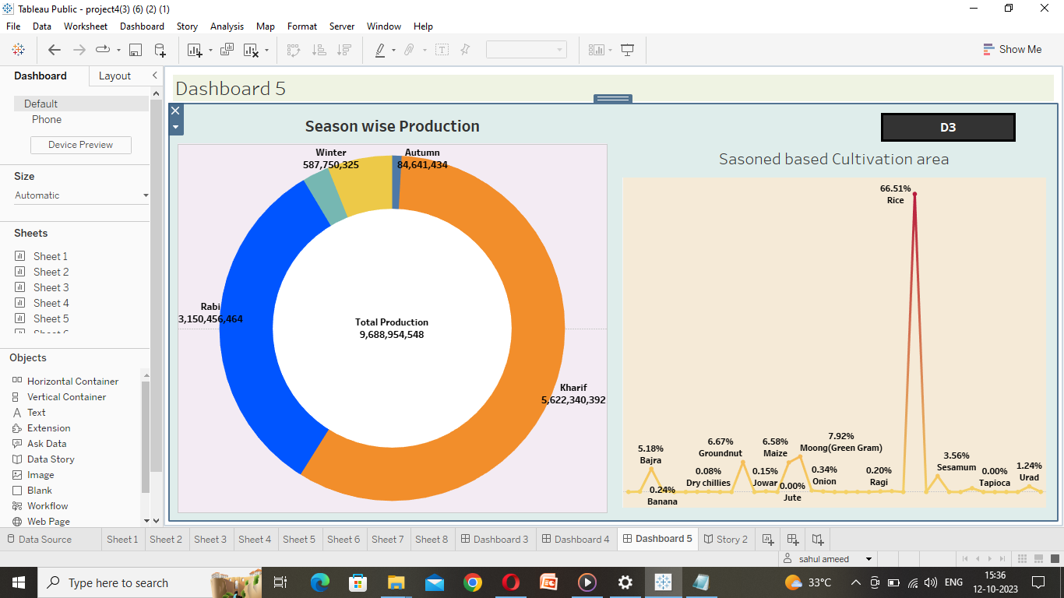

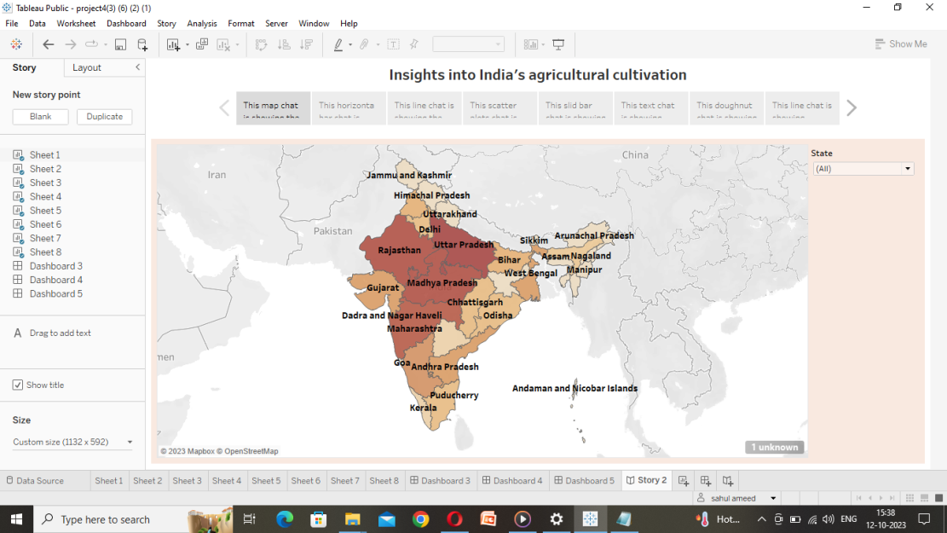

4. Advantage and Disadvantage:

Advantge: Agriculture impacts society in many ways, including: supporting livelihoods through food, habitat, and jobs; providing raw materials for food and other products; and building strong economies through trade. Source: The Balance Small Business.

Disadvantage: Modern farming methods have overused the natural resource base. Increased use of fertilizers has led to the loss of soil fertility. The use of groundwater for tube well irrigation has led to water depletion. Modern farming methods require a great deal of capital.

5. Application

i) Agriculture impacts society in many ways, including: supporting livelihoods through food, habitat, and jobs; providing raw materials for food and other products; and building strong economies through trade.

ii) There is over all increase in yield of crops mainly due to maintaining physical- chemical properties of soil. ...

iii) It helps in controlling insects, pests and soil borne diseases. ...

iv)Prevent or limit periods of peak requirements of irrigation water.

v)Uttar Pradesh is India's top farming state, with considerable state-level crop production including bajra, rice, sugarcane, food grains, and many others. It ranks first among India's wheat-producing states, ahead of Haryana, Punjab, and Madhya Pradesh.

6. Conclusion:

The agricultural sector is of vital importance for the region. It is undergoing a process of transition to a market economy, with substantial changes in the social, legal, structural, productive and supply set-ups, as is the case with all other sectors of the economy.

7. Future scope:

agriculture is good for the future as it is expected to use advanced technologies and innovations to produce more food with limited land and resources, increase efficiency on farms, and become more profitable, efficient, safe, and environment friendly.